Piling Ever Higher:

An Update on the State of Student Loans

# Introduction

Analysis of the 2016 Survey of Consumer Finances (SCF) suggests that a higher share of U.S. households was carrying student loan debt in 2016 than 2013, and that the amount of debt held by the typical borrower also increased markedly during that period. This research brief updates the findings of analysis of the 2013 Survey of Consumer Finances presented by Irene Lew (2015). This update finds that by many metrics, student loan debt has increased and become more burdensome for Americans of all ages, and that it is looming large for the youngest households, especially renter households. Incidence of student loan debt is particularly high and growing quickly for young households, but older households are also seeing higher rates of student loan incidence than in the past. Perhaps surprisingly, payment levels and burdens are not rising as quickly as total debt amounts, implying that households are finding payment plans that work with their budget, thereby opting for longer payback schedules. Many households are not yet making payments, however, and for the first time in the SCF data, young renters who are not yet in repayment on their student loans outnumber young renters who are in repayment. This paints a worrying picture both for these households and for the overall debt burden faced by U.S. households.

# The State of Student Loans

Over 22 percent of households had student loan debt in 2016, totaling 28 million households, with a median balance of $19,000, up from 20 percent of households with a median debt of $17,500 in 2013 (**Figure 1**).[1] This is substantially higher than the shares and median balances seen in 1989, the first year of SCF data, when 9 percent of households carried student loan debt with a median balance of $5,600. The total sum of student loan debt for all households reached $962 billion in 2016, according to the SCF. However, as mentioned in the previous JCHS brief, the SCF relies on self-reported finances, which may lead to underestimating total debt (Lew 2015). The Federal Reserve Bank of New York estimated that at the end of 2016, total student loan debt had reached $1.3 trillion, and by the third quarter of 2018, this estimate had grown to $1.4 trillion (Federal Reserve Bank of New York 2018).

The shares of households with student loan debt are increasing for all age groups, with the largest increases among households aged 30-39 and households aged 40-49 (**Figure 2**). The share of 30-39 year old households with student loan debt increased from 36 percent in 2013 to 41 percent in 2016, and the share of 40-49 year old households with student loan debt increased from 23 percent in 2013 to 28 percent in 2016. Over one million more 30-39 year old households had student loan debt in 2016 than 2013, despite the number of households in the age group dropping by 6,000; over 900,000 more 40-49 year old households had student loan debt in 2016 than 2013, despite the number of households in that age group dropping by nearly 500,000.

Of those households with student loan debt, 40 percent have over $25,000 in debt, with just over half of that share carrying over $50,000 in debt (**Figure 3**). This is an increase from 36 percent of households with over $25,000 in student loans in 2013, and the first time in the data that more than half of households with over $25,000 in debt were in the category of having over $50,000 in debt. In 2007, before the Great Recession, 32 percent of households with student loan debt had over $25,000 in debt, and only two in five of those households had over $50,000 in debt. In 2016, the median monthly student loan payment for those with between $10,000 and $25,000 in debt was $200, the median payment for those with between $25,000 and $50,000 was $290, and the median payment for household with more than $50,000 in debt was $500.

Though the shares of student loan borrowers with high amounts of debt are increasing, most borrowers still have less than $25,000 in debt. This is true across almost all degree types, with nearly 75 percent of borrowers without a degree, 60 percent of borrowers with an associate degree, and 55 percent of borrowers with a bachelor’s degree having less than $25,000 in student loans. Borrowers with graduate or professional degrees break this rule, however, with nearly half carrying student loan debt of over $50,000 in 2016 (**Figure 4**). However, these households also have higher levels of income and net wealth than those with bachelor’s degrees, associate degrees, or no degree (**Figure 5**).[2] In 2016, the median income for households with a graduate or professional degree in repayment on student loans was $108,000, and the median net wealth was $74,000. In contrast, the median income for households with a bachelor’s degree in repayment on student loans was $84,000 and the median net wealth was $69,000 in 2016. As a recent Urban Institute report found, the highest risk of delinquency was among those with less than $10,000 in student loan debt (Blagg 2018), suggesting that the amount of debt is not necessarily as predictive of delinquency as other factors like income or degree receipt.

While student loans are increasing in amount and incidence, payments are remaining relatively steady, and payment burdens do not appear to be growing quickly. The median monthly student loan payment in 2016 was $200, up from $175 in 2013 and $166 in 2010, but similar to the median payment of $190 in 2001, according to SCF data. Student loan burdens are calculated based on the ratio of monthly student loan payments to monthly income, and are categorized by the Department of Education as being low if they fall under 8 percent, medium if they fall between 8 and 14 percent, and high if they account for over 14 percent (US Department of Education 2018a). 85 percent of household borrowers in repayment on their student loans in 2016 had a low burden, 10 percent had a medium burden, and only 5 percent had a high burden (**Figure 6**). While these figures suggest that student loan payments remain near their 2001 levels, the dramatic growth in student loan balances remains concerning.

# How Student Loans are Affecting Young Households

As shown in **Figure 2**, young households are the most likely to hold student debt, with over 40 percent of both 20-29 year old households and 30-39 year old households holding student debt in 2016. These young households are also in their prime years for a variety of financial milestones, including first-time homebuying. This section therefore focuses on this subset of 20-39 year old households to describe several recent trends.

First, among households aged 20-39, black households were the most likely to be carrying student loans in 2016, even with a reduction in this share from 54 percent in 2013 to 51 percent in 2016. Of the other racial categories available in the SCF, 47 percent of non-Hispanic white households, 27 percent of Hispanic households, and 33 percent of all other racial category households aged 20-39 years old held student loan debt in 2016. The shares in these three groups increased from 2013 but still fell short of the incidence of student loans among young black households (**Figure 7**).

Higher educational attainment is associated with higher earnings, but among 20-39 year old households in repayment on their student loans (which excludes those still in school or otherwise deferring), carrying student loan debt presents a financial disadvantage. With an associate degree, for example, 20-39 year old households without student loan debt had a median net wealth of over $8,000 in 2016, but those with debt and in repayment had a median net wealth of -$3,700 (**Figure 8**). The gap is even wider for those with bachelor’s or graduate/professional degrees. The median net wealth for 20-39 year old households with a bachelor’s degree and no student loan debt was $26,900 in 2016, but for those with student loan debt and in repayment, median net wealth was -$6,100. These gaps also exist for median cash savings and assets, illustrating the financial obstacle posed by student loan debt.

It is unclear whether student loans directly affect homeownership, but there is a growing body of research trying to answer this question. For example, a 2017 national survey found that 76 percent of millennial student loan borrowers who are in repayment reported that student loans impacted their ability to purchase a home (National Association of Realtors and American Student Assistance 2017). A quantitative study analyzing the results of the National Longitudinal Survey of Youth found some evidence for student loans depressing homeownership, but only stemming from the presence of loans, not the amount (Houle and Berger 2015) – which would still translate in depressed homeownership, given the growth in incidence. Another study found that the rise in tuition and debt during the 2000s contributed to at least part of the decline in homeownership for young households (Bleemer et al. 2017).

One piece of evidence that the SCF can provide to help determine the relationship between student loans and homeownership is detailing the financial difficulties faced by young renter households. As **Figure 8** showed, households with student loan debt are financially worse off than those without, and it stands to reason that delays in repayment will only prolong these disadvantages. In 2016, for the first time in SCF data, over half of renter households aged 20-39 years old who carried student loan debt were in deferment on their student loans – 4.7 million households, compared to the 4.2 million households in repayment on their student loans (**Figure 9**). In 2013, 3.6 million 20-39 year old renter households were in deferment, while 4.5 million households were making payments. This growth in deferment may be due to rising numbers of students pursuing undergraduate and postgraduate education and deferring while in school, or it could be due to growth in any number of other reasons that make borrowers eligible for deferment or forbearance, including economic hardship, unemployment, and military service (US Department of Education 2018b).

Whatever the reason for the growth in the number of households not making payments on student loans, the amount owed by young renter households not making payments exceeds the amount owed by those who are making payments. The total amount of student loan debt owed by 20-39 year old renter households not in repayment was $163 billion in 2016, up from $130 billion in 2013 and exceeding the $144 billion owed by 20-39 year old renter households in repayment in 2016 (**Figure 10**). While 2016 was the first year in which a majority of young renter households were not in repayment, the amount owed by these households has exceeded the amount owed by households in repayment since 2010, when those not in repayment owed $103 billion and those in repayment owed $78 billion. These figures suggest that the recent growth in student loan debt is only likely to continue in coming years.

# Conclusion

As other researchers have pointed out, rising tuition costs are not deterring people from pursuing higher education, but instead resulting in more students turning to loans to finance growing costs (Bleemer et al. 2017). It stands to reason, then, that the incidence and amount of student loans has been increasing substantially, and that many different types of households now carry student loan debt. This analysis found that more than one in five U.S. households were carrying student loan debt in 2016, with a median balance of just under $20,000, and this incidence and debt load were both higher than in 2013. Student loans are most common for young households, and this analysis also found that among those young households with a degree, debt posed a serious barrier to building cash savings and net wealth. Student debt loads have been increasing steadily in the SCF since 1998, and this analysis found that the number of households deferring payments and the amount of debt in deferment have been growing as well, perhaps more rapidly. With enrollment in higher education continuing to grow, these trends in student loan debt can be expected to continue, posing challenges for a wide variety of households.

# Figures

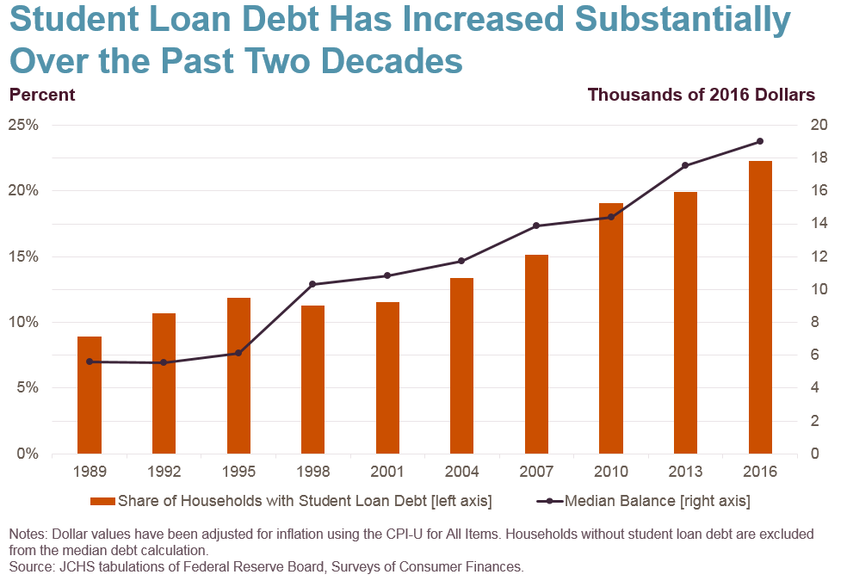

Figure 1: Student loan debt incidence and amounts since 1989

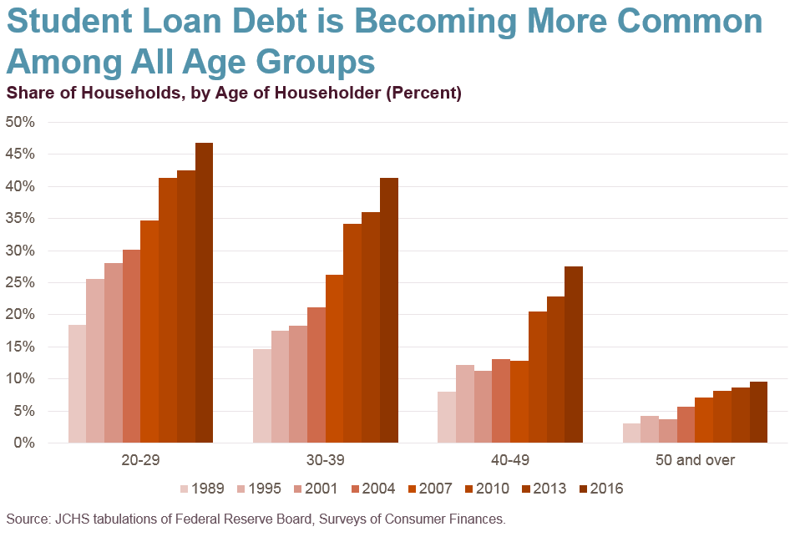

Figure 2: Student loan debt by age group

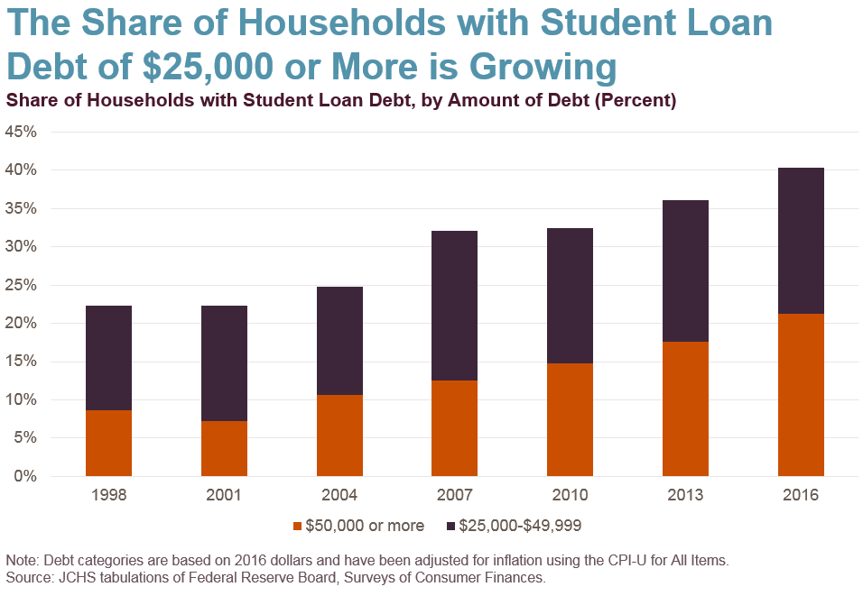

Figure : Share of HHs with over $25k in student loans, of HHs with student loans

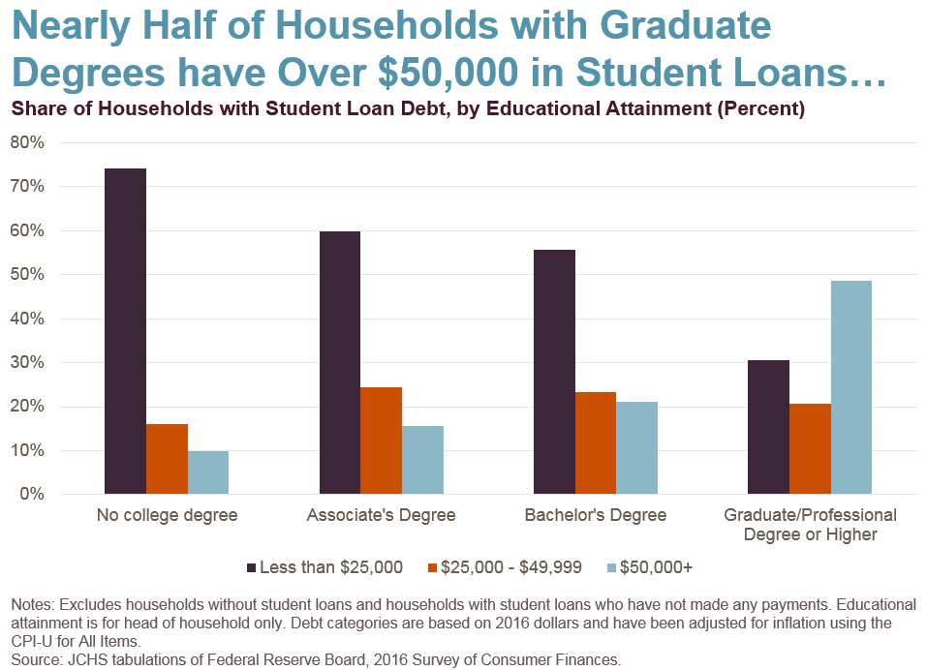

Figure : HH student loan debt amounts by educational attainment

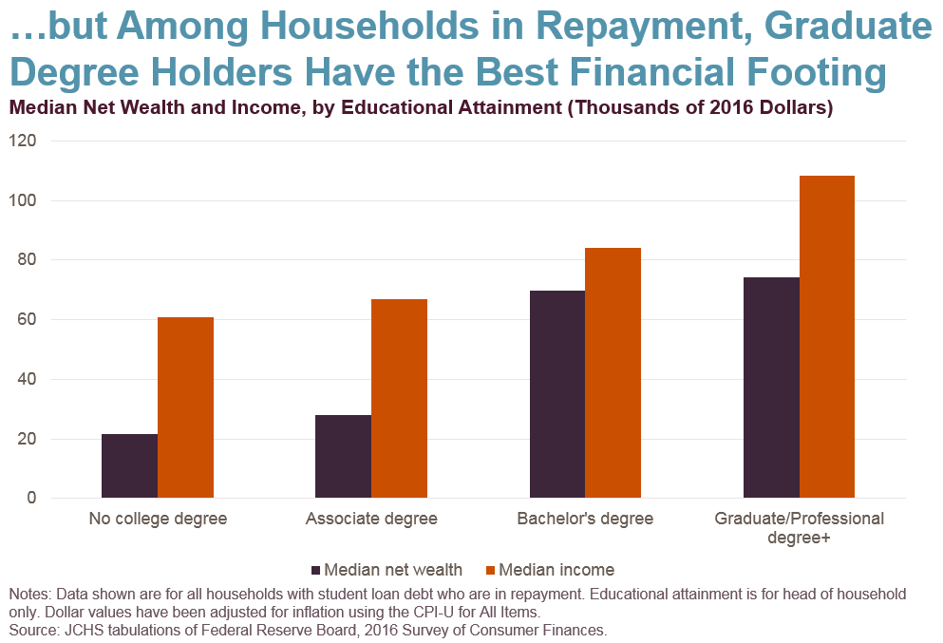

Figure : HH net wealth and income by educational attainment

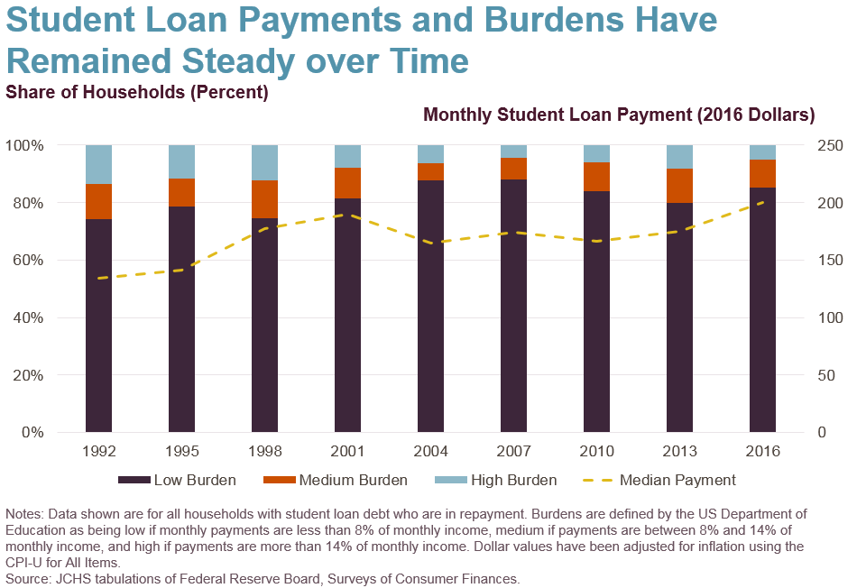

Figure 6: Student loan debt burdens and median payments

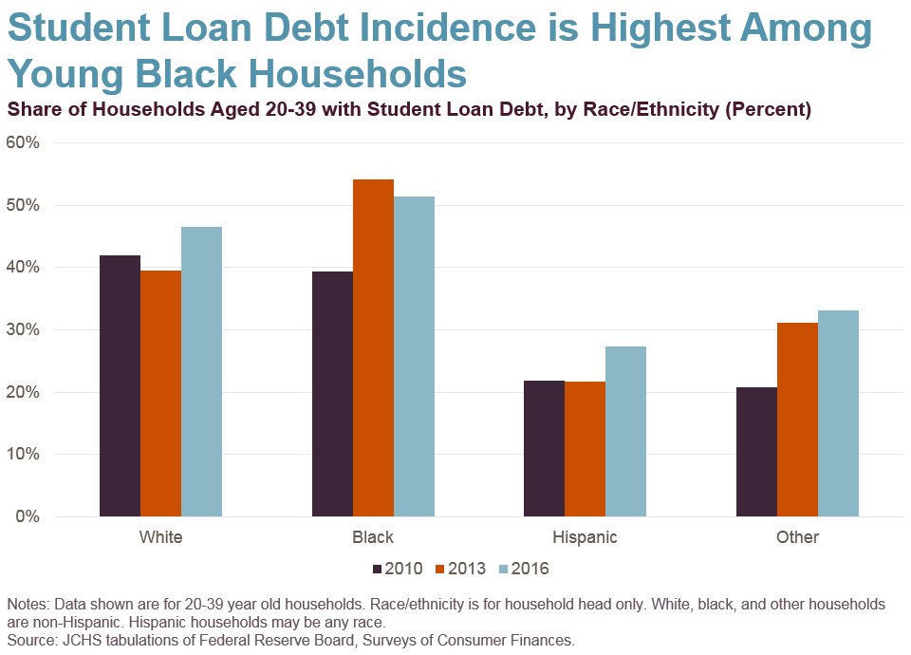

Figure : Student loan debt incidence by race/ethnicity

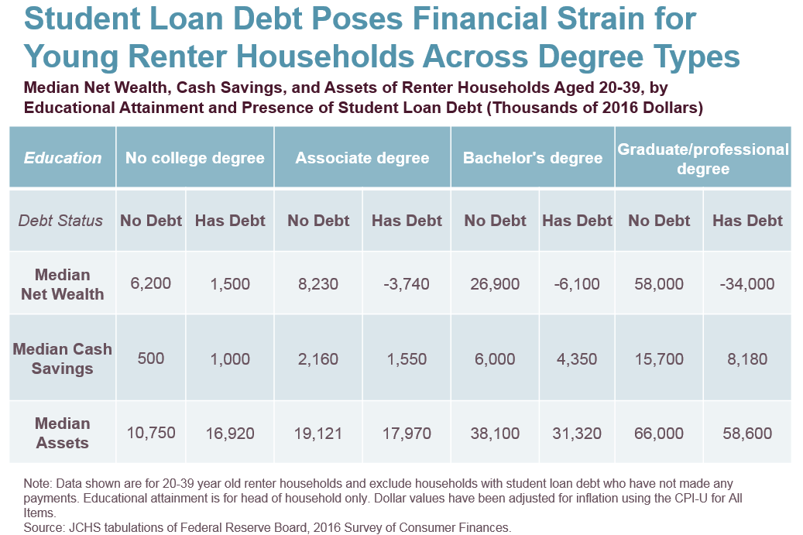

Figure : Financial indicators by educational attainment and loan holding status

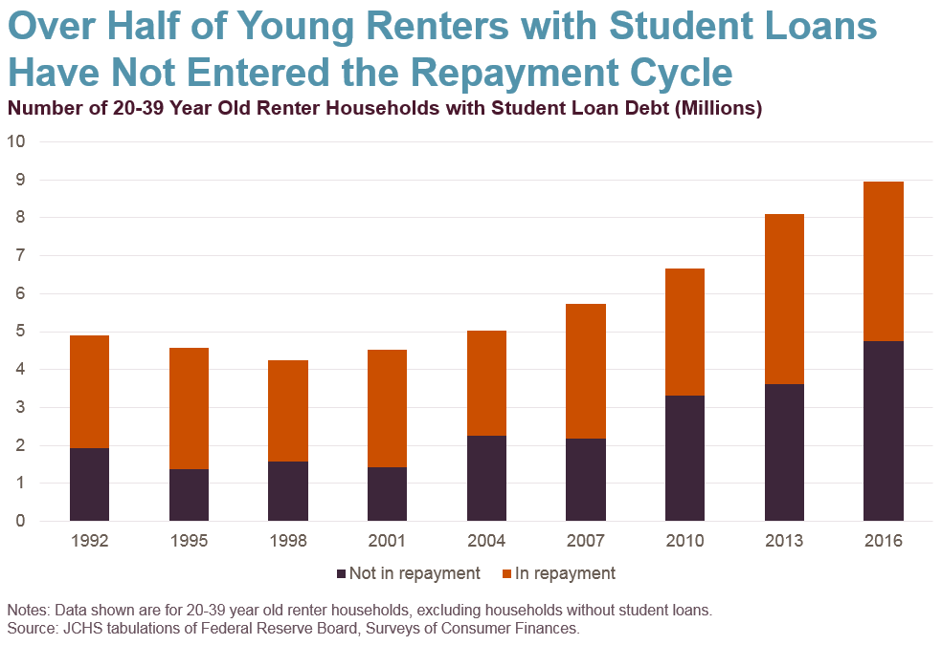

Figure : Student loan debt for 20-39 year old renter households by repayment status

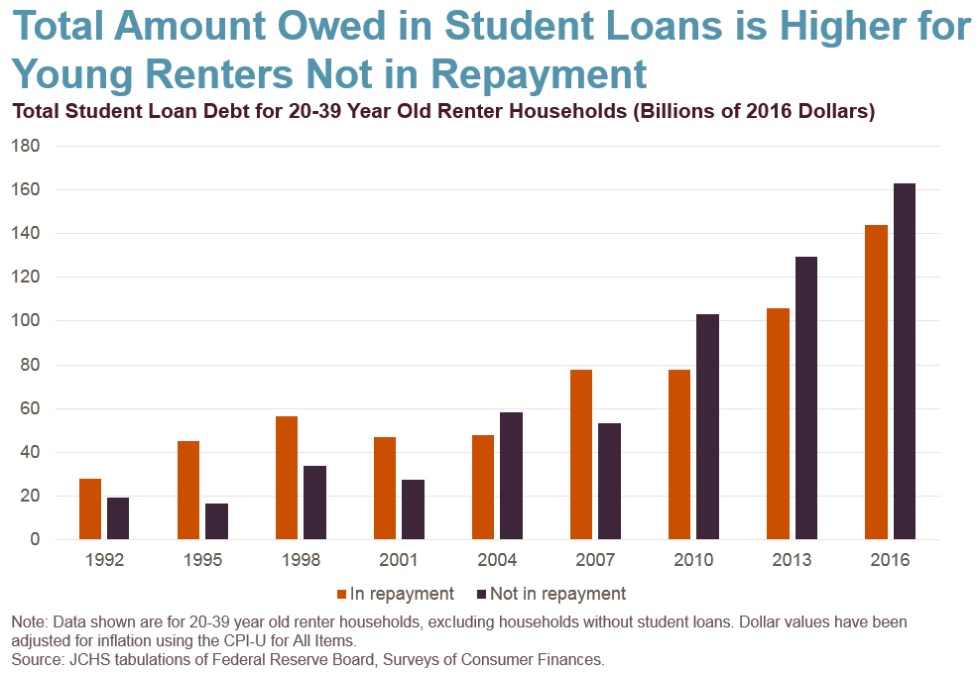

Figure : Student loan debt for 20-39 year old renter households by repayment status

# Works Cited

Blagg, Kristin. 2018. “Underwater on Student Debt.” Urban Institute. https://www.urban.org/research/publication/underwater-student-debt.

Bleemer, Zachary, Meta Brown, Donghoon Lee, Katherine Strair, and Wilbert van der Klaauw. 2017. “Echoes of Rising Tuition in Students’ Borrowing, Educational Attainment, and Homeownership in Post-Recession America.” *Federal Reserve Bank of New York: Staff Reports* 820. https://www.newyorkfed.org/research/staff_reports/sr820.

Federal Reserve Bank of New York. 2018. “Quarterly Report on Household Debt and Credit.” https://www.newyorkfed.org/microeconomics/databank.html.

Houle, Jason N., and Lawrence Berger. 2015. “Is Student Loan Debt Discouraging Homeownership among Young Adults?” *Social Service Review* 89 (4): 589–621. https://doi.org/10.1086/684587.

Joint Center for Housing Studies. 2018. “The State of the Nation’s Housing 2018.” Harvard University.

Lew, Irene. 2015. “Student Loan Debt and the Housing Decisions of Young Households.” Joint Center for Housing Studies of Harvard University. http://jchs.harvard.edu/sites/jchs.harvard.edu/files/lew_research_brief_student_loan_11_2015.pdf.

National Association of Realtors, and American Student Assistance. 2017. “Student Loan Debt and Housing Report 2017.” https://www.nar.realtor/sites/default/files/documents/2017-student-loan-debt-and-housing-09-26-2017.pdf.

US Department of Education. 2018a. “Glossary.” StudentLoans.Gov. 2018. https://studentloans.gov/myDirectLoan/glossary.action.

———. 2018b. “Deferment and Forbearance.” Federal Student Aid. October 29, 2018. https://studentaid.ed.gov/sa/repay-loans/deferment-forbearance.

1. All dollar amounts contained in this brief are real 2016 dollars, adjusted for inflation using the CPI-U for All Items.
2. Because many student loan borrowers in deferral may still be in school, this figure is limited to student loan borrowers in repayment. Repayment status is determined using SCF data, based on whether a household has student loan debt and whether that household has any monthly student loan debt payments. If a household has debt but not payments, they are classified as being in deferment.